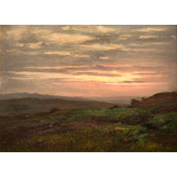
PAINTINGS

Bannister, Edward Mitchell (American, 1828 - 1901)
Passed Storm, ca. 1880
Oil on artist board
Dimensions: 6 1/4 x 8 1/4 in. (15.9 x 21 cm)
Museum: Montclair Art Museum
Museum purchase; funds provided by Dr. Arthur Hunter in memory of Ethel Parsons Hunter
2003.21
Edward Bannister was a prominent member of the Providence, Rhode Island art community and instrumental in the founding of the Rhode Island School of Design. In 1876 he became the first African American artist to win major recognition in a public forum, the Philadelphia Centennial Exposition of 1876. Largely self-taught, Bannister was introduced in the 1850s to the paintings of the Barbizon school. Like Millet and his followers working in the French countryside, Bannister recorded intimate glimpses of nature first around Boston and ultimately in Rhode Island where he settled in 1870. This painting is typical of his dramatic views of the Narragansett landscape with its fields and shorelines which speak of his reverence for nature. Like his contemporary George Inness, Bannister believed that the artist "becomes an interpreter of the infinite, subtle qualities of the spiritual idea [of nature]…revealing glimpses of absolute harmony."

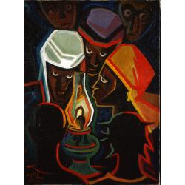
PAINTINGS
Jones, Lois Mailou (American, 1905-1998)
Blackout in Haiti, 1964 Oil on burlap
frame: 37 x 29 1/2 in. (94 x 74.9 cm)
painting: 29 x 21 in. (73.7 x 53.3 cm)
Gift of John and Elsbeth Dusenbery 1991.14
Museum: Montclair Art Museum
Lois Mailou Jones has played a major role in teaching and promoting art by African Americans. A thriving freelance fabric and textile designer, in 1930 Jones began a lifelong career as an instructor in the art department at Howard University in Washington, D.C. Jones's first trip to Paris in 1937, formed a turning point in her career as she studied African and modern art. Shortly after this visit, she met Alain Locke, chair of Howard University's philosophy department, who encouraged her to explore her African American cultural heritage. In 1953 she married the noted Haitian graphic artist and designer Vergniaud Pierre-Noel. Jones first traveled to Haiti in 1954, when she was invited by the Haitian government to teach at the Centre d'Art and at the Foyer des Arts Plastiques. During the next thirty years, Jones visited Haiti often and adopted a variety of approaches to capturing the vitality of Haitian life, as she responded to the work of native artists.
Blackout in Haiti reveals her modernist tendency to simplify and condense forms within a
shallow space. The decorative, hard-edged style and geometric planar forms of this work suggest Jones's experiences as a designer and her early absorption of Cubism. The subject of this work - a group huddled around candlelight during an electrical outage - suggests her sympathetic awareness of the impoverished Haitians' hardships and their devout religious beliefs.

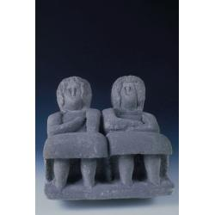
SCULPTURE
Edmondson, William (American, 1874-1951)
Po'ch Ladies, ca. 1941
Limestone
sculpture: 11 3/4 x 13 1/2 x 15 1/2 in. (29.8 x 34.3 x 39.4 cm)
Museum purchase; funds provided by The William Lightfoot Schultz Foundation
1973.2
Museum: Montclair Art Museum
A self-taught sculptor and the son of former slaves, William Edmondson was born in Nashville, Tennessee. In 1937, he became the first African American artist to have a one-person show at New York's Museum of Modern Art. Edmondson didn't begin sculpting until he was almost sixty years old, when he took up stone carving as the result of a divine vision. Using limestone blocks from demolished buildings and curbs, and hand-made tools, he began to carve tombstones as well as freestanding figures. He took as his subjects the people surrounding him - preachers, nurses, and schoolteachers - as well as Biblical figures, angels, birds, and animals. Like most of Edmondson's sculpture, Po'ch Ladies retains the original shape of the limestone block from which it was carved. The simplified forms have a nearly abstract quality. Only the essential details of the two figures are indicated, from the round eyes, protruding noses, incised mouths, and helmeted hairdos to the mitt-like hands and stocky, footless legs. The reposed and static posture of the figures suggests the relaxation of a porch swing or rocking chair.

Escape from Slavery: The True Story of My Ten Years in Captivity - and My Journey to Freedom in America

ISBN-13: 9780312306236
Publisher: St. Martin's Press
Publication date: 09/28/2003
Edition description: First Edition
Pages: 288
Product dimensions: 5.76(w) x 8.56(h) x 1.11(d)
Overview
Escape from Slavery: The True Story of My Ten Years in Captivity - and My Journey to Freedom in America by Francis Bok, Edward Tivnan In this groundbreaking modern slave narrative, Francis Bok shares his remarkable story with grace, honesty, and a wisdom gained from surviving ten years in captivity.

http://50.199.148.5:8081/view/objects/asitem/search@/1/primaryMaker-asc?t:state:flow=fefe8ead-680f-4760-8bbc-c4003dd890ef
http://50.199.148.5:8081/view/objects/asitem/search@/8/primaryMaker-asc?t:state:flow=e37e40e5-340e-43dd-b39f-b3c20550f65e
http://50.199.148.5:8081/view/objects/asitem/search@/6/primaryMaker-asc?t:state:flow=7add2238-fba1-4b12-996b-f9596ec7d2e8
https://www.barnesandnoble.com/w/escape-from-slavery-francis-bok/1100626244?ean=9780312306236

